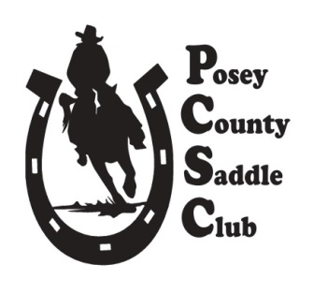
Club Officers
President – Melinda Griffin 812-202-1200
Vice President- Kim Nesbitt 270-748-0626
Secretary – Jacque Miller 812-598-2266
Treasurer – Open
Website/Facebook – Ivy Lutz 812-618-8556
Point Keeper – Keely Burkhart 812-319-5452

JULY NEWSLETTER
POSEY COUNTY SADDLE CLUB

Another successful show was held in June and our next one is right around the corner! We welcomed several more new members at the last show, so keep telling your horse friends about our amazing little Club. Construction supplies and equipment for the new 4-H structure are still being stored on the grassy parking area, so continue to use caution and courtesy when maneuvering around that zone.

Our next meeting is 6 pm on July 8th at the Junior Leaders Booth next to the arena. Contact Melinda Griffin with any questions.

Open Contest-Only show on Saturday July 11th at noon. We will offer paybacks of $25 for 1st Place, $15 for 2nd Place, and $10 for 3rd Place. Divisions consist of Pee-Wee, Junior, and Open classes for riders of any age, but participants must be a current member with signed liability form. A special thank you goes to the Isaac Family, Blazing Saddles 4-H Horse & Pony Club, Serenity Horsemanship, Kem Luckett, William and Sandra Mumford, the Sincroft Family, the Miller Family, Sue Aldrich, Jaclynn and Chris Greathouse, Brock Concessions, and Scott and Melinda Griffin for sponsoring classes!

THANK YOU to all the volunteers who contribute to each show to running smoothly. Please consider how YOU can serve the Club because an hour here and there is greatly needed and appreciated! The Club needs:

- Volunteers to work the gate, setup, hand out ribbons, and announce on show days
- Volunteers to work in the air-conditioned office
- Club treasurer
- Help with the end-of-year banquet

Please come to the monthly meeting, contact Melinda Griffin, or comment on our Facebook sign-up posts to let us know where your talents can best serve the Club.

T-Shirts – The Club is looking for future t-shirt designs, so please submit your ideas to Melinda Griffin. The Club only ordered a few to sell, so pick yours up at the office on show day for $17. 2025 shirts are discounted to $12, and 2024 shirts are on super sale for only $10!

Do you shop at Tri-State Equine and Pet? Mention “Posey County Saddle Club” at checkout and we will receive a small percentage back at no extra cost to you! Those pennies add up quickly making this an easy, year-round fundraiser!

Upcoming Dates to remember:

- Wednesday July 8th – Business meeting 6:00 p.m. Jr Leaders Booth @ fairgrounds (old dining hall in inclement weather)
- Saturday July 11th – OPEN Contest-only Show depending on weather
- Wednesday August 12th – Business meeting 6:00 p.m.
- Saturday August 15th – Horse Show depending on weather

2026 SHOW DATES

**April 18** **May 16** **June 20** **July 11 (contest-only)** **August 15** **September 19** **October 17**

